November |  |  |  |  | 2019
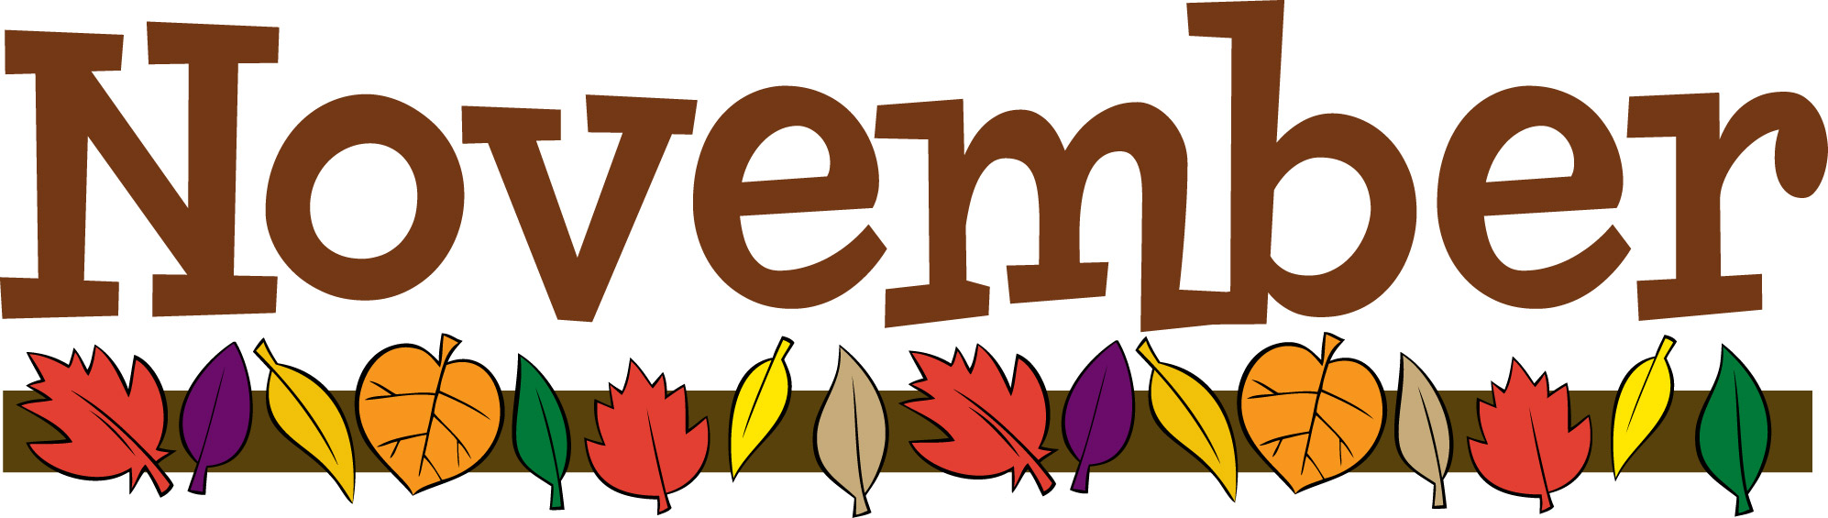
Sunday | Monday | Tuesday | Wednesday | Thursday |  | Friday | Saturday
 |  |  |  |  |  | 1 | 2
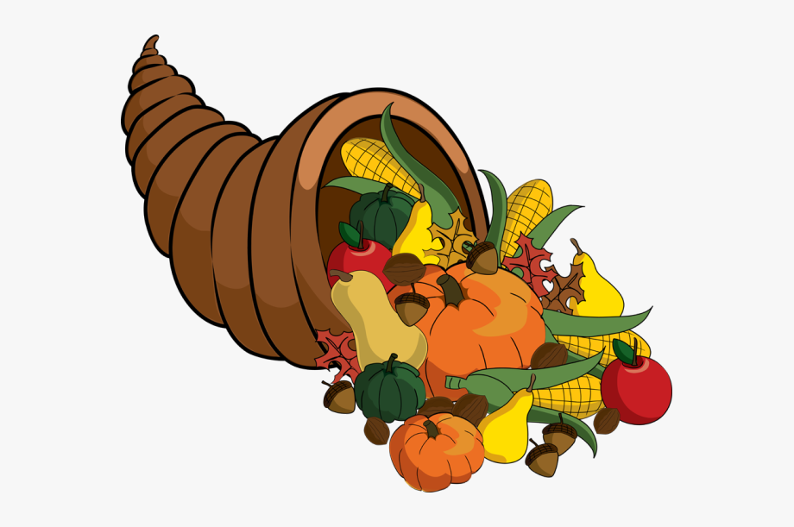 |  |  |  |  |  | Regular Classes | 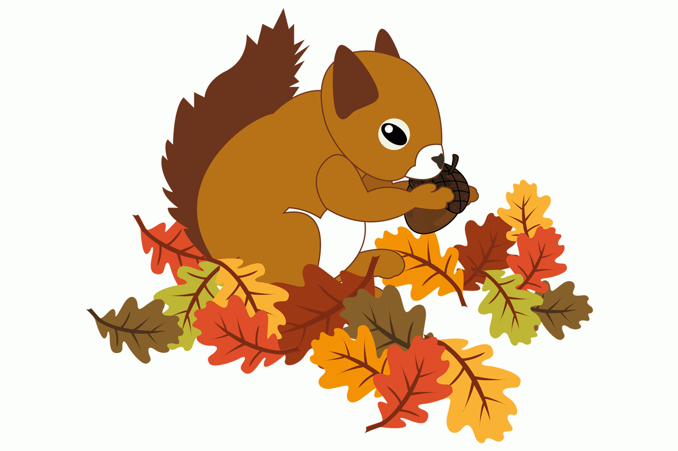
3 | 4 | 5 | 6 | 7 |  | 8 | 9
 | Regular Classes  Class Committee Meeting 2A,2B | Regular Class  Class Committee Meeting 3A,3B ,3c | DAPC Elections  Class Committee Meeting 4A,4B | Regular Classes |  | Walk-A-Thon  (Healthy Relationships
10 | 11 | 12 | 13 | 14 |  | 15 | 16
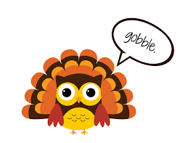 | Regular Classes | Regular Classes | Managing Stress During the Holidays 830am | Regular Classes |  | DAPC Ceremony10am
17 | 18 | 19 | 20 | 21 |  | 22 | 23
 | Regular Classes | Regular Classes | Regular Classes | Regular Classes |  | Regular Classes
24 | 25 | 26 | 27 | 28 |  | 29 | 30
 | Regular Classes | Parent General Meeting 830am  Friends & Family Celebration 11am | No Classes  In-service Training | Thanksgiving  Center Closed |  | Center Closed  No Classes
